Grade 7 Accelerated · Unit 6 · Thread B · Day 1  Angle Pairs: Supplementary, Complementary, Vertical, Adjacent  Question Bank 6.T1 | Name______________________  Date______________________  Period____________________

Show your work. Circle your final answer.
For questions 1 through 4, find the angle.
1. The complement of 17°

2. The supplement of 95°

3. The angle vertical to a 128° angle

4. The angle that makes a linear pair with a 41° angle

For questions 5 through 7, find x and the angles.
5. 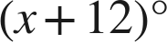 and 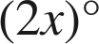 are complementary.

6. 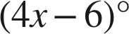 and 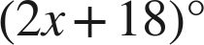 are a linear pair.

7. Vertical angles measure 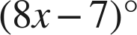 and 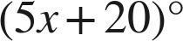.

Choose one.
8. Angles M and N are supplementary, and angle M is 64°. What is angle N?
○ A. 26°
○ B. 116°
○ C. 64°
○ D. 244°

9. Vertical angles measure 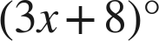 and 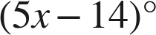. A student answers 11. What did the student find?
○ A. the angle
○ B. the value of x
○ C. the supplement
○ D. the complement

